A Project Report On
DEEP LEARNING BASED HUMAN DETECTION AND RECOGNITION FOR CONTACTLESS DOORBELL SYSTEMS

Submitted by
Ms. KANCHARLA SAHITHI KRISHNA SRI 21ME1A05F8 Ms. PAPANI NAGA DHANALAKSHMI 21ME1A05H5
Ms. GANGULA KALYANI 21ME1A05E7 Ms. BORRA JYOTHIKA VENKATA NAGA SAI 21ME1A05D9
Submitted in partial fulfillment of the requirement for the award of the degree of

BACHELOR OF TECHNOLOGY
in

COMPUTER SCIENCE AND ENGINEERING
Under the Esteemed Guidance of
Mr. Y. NAGENDRA KUMAR M. Tech, (Ph.D)
Associate Professor

DEPARTMENT OF CSE

Department of Computer Science and Engineering
RAMACHANDRA COLLEGE OF ENGINEERING (AUTONOMOUS)
(Approved by AICTE, PermanantlyAffiliated to JNTUK, Kakinada) Accredited by NBA and NAAC (A+)
NH-16 Bypass, Vatluru (V), ELURU-534007, Eluru Dist., A.P.

2024–2025

RAMACHANDRA COLLEGE OF ENGINEERING
(AUTONOMOUS)
(Approved by AICTE, Permanently Affiliated to JNTUK, Kakinada) Accredited by NBA and NAAC (A+)
NH-16 Bypass, Vatluru (V), ELURU-534007, Eluru Dist., A.P.
2024–2025
Department of Computer Science and Engineering

BONAFIDE CERTIFICATE
This is to certify that this project report entitled “DEEP LEARNING BASED HUMAN DETECTION AND RECOGNITION FOR CONTACTLESS DOORBELL SYSTEMS” is being submitted by K. S. KRISHNA SRI (21ME1A05F8), P. N. DHANALAKSHMI (21ME1A05H5), G. KALYANI(21ME1A05E7), and B. J. V. NAGA SAI (21ME1A05D9)
in partial fulfillment of BACHELOR OF TECHNOLOGY in COMPUTER SCIENCE AND ENGINEERING.
This report is a bonafide work carried out under my guidance and supervision during the academic year 2024-2025 and it has been found worthy of acceptance as per the requirements of the university.

PROJECT GUIDE HEAD OF THE DEPARTMENT
Mr. Y. NAGENDRA KUMAR M. Tech, (Ph.D) Dr. G. CHAMUNDESWARI
Associate Professor M. Tech., Ph. D.

Internal Examiner External Examiner

DECLARATION

We, KANCHARLA SAHITHI KRISHNA SRI (21ME1A05F8), PAPANI NAGA DHANALAKSHMI (21ME1A05H5), GANGULA KALYANI (21ME1A05E7), and
BORRA JYOTHIKA VENKATA NAGA SAI (21ME1A05D9) hereby declare that the project report titled “DEEP LEARNING BASED HUMAN DETECTION AND RECOGNITION FOR CONTACTLESS DOORBELL SYSTEMS” has been completed
under the supervision of Mr. Y. Nagendra Kumar, Associate Professor, Department of Computer Science and Engineering. This report is submitted in partial fulfillment of the requirements for the award of the degree of BACHELOR OF TECHNOLOGY in COMPUTER SCIENCE AND ENGINEERING.
This is a record of work carried out by us, and the results presented in this project have not been reproduced or copied from any source. Furthermore, the results embodied in this project report have not been submitted to any other University or Institute for the award of any other degree or diploma.

ACKNOWLEDGEMENT

We take this opportunity to express our sincere gratitude to all those who have contributed to the successful completion of our research work. Their guidance, support, and encouragement have been invaluable throughout this journey.
We extend our heartfelt thanks to our supervisor, Mr. Y. Nagendra Kumar, Associate Professor, Department of Computer Science and Engineering, for his invaluable mentorship, insightful guidance, and unwavering support throughout the course of this research. His expertise and constructive feedback have been instrumental in shaping this work.
We are deeply indebted to Dr. G. Chamundeswari, Head of the Department, Computer Science and Engineering, for her continuous encouragement, guidance, and support in all aspects of this research endeavor.
Our sincere recognition also goes to Dr. M. Muralidhara Rao, Principal for his invaluable suggestions and constructive inputs during the preparation of this research work.
We also wish to convey our sincere thanks to all the Deans for their constant encouragement and insightful suggestions that have greatly contributed to the progress of this research.
We extend our profound gratitude to the Management of Ramachandra College of Engineering, Eluru, for their unwavering support, encouragement, and for providing the necessary facilities to successfully carry out this project.
We would also like to express our deepest recognition to all the faculty members and staff of the Department of CSE for their valuable advice, insightful suggestions, and continuous motivation, which have played a crucial role in the successful completion of this research.
Finally, we extend our sincere gratitude to everyone who has directly or indirectly contributed to the successful completion of this research work. Their support and encouragement have been truly invaluable.

Ms. KANCHARLA SAHITHI KRISHNA SRI 21ME1A05F8 Ms. PAPANI NAGA DHANALAKSHMI 21ME1A05H5 Ms. GANGULA KALYANI 21ME1A05E7 Ms. BORRA JYOTHIKA VENKATA NAGA SAI 21ME1A05D9

Chapter No |  | Title | Page No
1. | Abstract  Introduction |  | VIII  1
  - Introduction 1
  - Overview of the Project 2
  - Objective 2 - 3
  - Scope 3
  - Expected Outcome 4

2. Literature Survey | 5 - 6
3. System Analysis | 7
3.1 Existing System | 7 - 8
3.2 Proposed System | 9 - 10
4. System Study | 11
4.1 Feasibility Study | 11
4.1.1 Operational Feasibility | 11 - 12
4.1.2 Economic Feasibility | 12 - 13
4.1.3 Technical Feasibility | 13 - 14
4.2 System Requirements | 15
4.2.1 Hardware Requirements | 15
4.2.2 Software Requirements | 15
5. Project Architecture | 16
5.1 System Architecture | 16
5.2 Design and Diagrams | 17
5.2.1 Usecase Diagram | 17
5.2.2 Class Diagram | 18 - 19
5.2.3 Sequence Diagram | 20
5.2.4 Collaboration Diagram | 21
5.2.5 Data Flow Diagram | 22
6. Methodology | 23
6.1 Data Dictionary | 23
6.2 Data Collection | 24
6.3 Preprocessing Techniques | 25
6.4 Prepared Data | 26

V

Chapter No Title Page No
- Model 27
  - Training 27 - 29
  - Validation 29 - 31
- Software Description 32 - 33
- System Testing 34
  - Literature on Testing 35
    - Unit Testing 37
    - Integration Testing 38
    - Acceptance Testing 39
  - Test cases on Project 40 - 41
- Coding 42 - 48
- Results 49
  - Screenshots 49 - 52
  - Conclusion & Limitations 53
  - Future Scope 54
- References & Bibliography 55 - 56

VI

List of Tables

Table no. | Table Name | Page No.
Table 2.1 | Literature survey | 5
Table 9.2 | Test Cases | 41
List of Figures

Figure No. | Figure Name | Page No.
Figure 5.1.1 | Flow chart Representing smart contactless doorbell and alert mechanism | 16
Figure 5.2.1 | Usecase Diagram for Smart Contact Less Door Bell | 17
Figure 5.2.2 | Class Diagram for Smart Contact Less Door Bell | 18
Figure 5.2.3 | Sequence Diagram for Smart Contact Less Door Bell | 20
Figure 5.2.4 | Collaboration Diagram for Smart Contact Less Door Bell | 21
Figure 5.2.5 | Dataflow diagram for Smart Contact Less Door Bell | 22
Figure 7.1.3 | Training for face Recognition | 28
Figure 7.2 | Validation | 30
Figure 11.1.1 | Web page Interface | 49
Figure 11.1.2 | Known Person Detection | 50
Figure 11.1.3 | Unknown Person Detection | 51
Figure 11.1.4 | Email Alert | 52

ABSTRACT

The Smart Doorbell System is a Python-based application designed to enhance home security through real-time face recognition and automated alerting. Leveraging advanced libraries such as OpenCV and Face Recognition, the system identifies individuals at the doorstep by comparing detected faces with a preloaded dataset of known faces. When an unknown person is detected, the system captures their photo, saves it locally, and sends an immediate email alert to the homeowner with the attached image for further action. Additionally, the system provides real-time video streaming via a user-friendly web interface, allowing users to monitor their doorstep remotely. Built using Flask for the backend, the application supports features like starting/stopping the camera and handling email-based commands for remote control. With its seamless integration of face recognition, email alerts, and video streaming, the Smart Doorbell System offers a robust and efficient solution for modern home security needs. This project demonstrates the practical application of machine learning and computer vision technologies in everyday life, offering a cost-effective and efficient solution for modern home security. Whether used in residential settings, offices, or other secure environments, the Smart Doorbell System provides a reliable and intelligent way to monitor and respond to visitors, ensuring peace of mind for users. By combining cutting-edge technology with user-friendly design, this system represents a significant step forward in the evolution of smart home security solutions.

CHAPTER 1 INTRODUCTION

INTRODUCTION
In today’s fast-paced world, ensuring the safety and security of our homes and workplaces has become more important than ever. Traditional doorbell systems, while functional, lack the intelligence and automation needed to address modern security challenges. The Smart Doorbell System is an innovative solution designed to bridge this gap by leveraging the power of artificial intelligence (AI), computer vision, and real-time communication technologies. This project aims to provide a smarter, more efficient way to monitor and respond to visitors, enhancing both convenience and security.
The Smart Doorbell System is a Python-based application that integrates face recognition and real-time video streaming to identify individuals at the doorstep. By comparing detected faces with a preloaded dataset of known faces, the system can distinguish between familiar visitors and unknown individuals. When an unknown person is detected, the system captures their image, saves it locally, and sends an instant email alert to the homeowner, complete with the attached photo for quick identification and action. This feature ensures that homeowners are promptly informed of potential security concerns, even when they are away from home.
In addition to face recognition and alerting, the system provides a user-friendly web interface for real-time video streaming and remote control. Built using the Flask web framework, the interface allows users to start or stop the camera, view live video feeds, and handle email-based commands for remote actions such as unlocking the door or sounding an alarm. The integration of SMTP and IMAP protocols ensures seamless communication for email alerts and command handling, while the playsound library adds an auditory alert feature, such as ringing a doorbell sound when a known person is detected.
Future enhancements could include integration with mobile apps for push notifications, cloud storage for saving detected images, and support for multiple cameras to cover larger areas.

Overview of the Project

The Smart Contactless Doorbell System is an innovative, AI-powered solution designed to enhance security and convenience by integrating contactless technology, real-time face recognition, and automated alerting. Unlike traditional doorbells, this system uses computer vision and machine learning to detect and identify individuals at the doorstep without requiring physical interaction. By leveraging libraries like OpenCV and Face Recognition, it compares detected faces with a preloaded dataset of known faces, distinguishing between familiar visitors and unknown individuals. When an unknown person is detected, the system captures their image, saves it locally, and sends an instant*email alert to the homeowner with the attached photo for quick action. This ensures users are promptly informed of potential security concerns, even when they are away.
The system also features real-time video streaming through a Flask-based web interface, allowing users to monitor their doorstep remotely. It supports email-based commands for remote actions like unlocking doors or sounding alarms, making it highly interactive and user-friendly. The integration of SMTP and IMAP protocols ensures seamless communication, while the playsound library adds auditory alerts, such as ringing a doorbell sound for known visitors. Designed for modularity and scalability, the system can be extended with features like mobile app integration, cloud storage, and multi-camera support. Ideal for homes, offices, and public spaces, the Smart Contactless Doorbell System offers a secure, intelligent, and hygienic solution for modern security needs.

Objective
The primary objective of this project is to develop an intelligent and hygienic security solution that leverages advanced technologies to enhance safety and convenience. The system aims to eliminate the need for physical interaction by using real-time face recognition powered by AI and computer vision to identify known and unknown individuals at the doorstep. When an unknown person is detected, the system captures their image and sends an instant email alert to the homeowner, complete with the attached photo for quick identification and action.

Additionally, the project focuses on providing remote monitoring capabilities through a user-friendly web interface, enabling users to view live video feeds and control the system via email-based commands, such as unlocking doors or sounding alarms.
By integrating SMTP and IMAP protocols for seamless communication and incorporating auditory alerts like doorbell sounds for known visitors, the system ensures a responsive and interactive user experience. Designed with modularity and scalability in mind, the project aims to create a cost-effective and adaptable solution that can be extended with features like mobile app integration and cloud storage. Ultimately, the Smart Contactless Doorbell System demonstrates the practical application of AI, computer vision, and IoT technologies in addressing modern security challenges, making it suitable for homes, offices, and public spaces.

Scope
The Smart Contactless Doorbell System has a wide scope, offering a modern and intelligent solution for enhancing security and convenience in various environments. It is designed for residential use, providing homeowners with real-time face recognition, instant email alerts for unknown visitors, and remote monitoring capabilities. Additionally, the system is suitable for workplaces, hospitals, and public spaces, where contactless interactions are increasingly preferred for hygiene and safety. Its modular and scalable design allows for future enhancements, such as integration with mobile apps for push notifications, cloud storage for saving detected images, and support for multiple cameras to cover larger areas. By leveraging AI, computer vision, and IoT technologies, the project demonstrates the potential for smart, automated systems to address modern security challenges, making it a versatile and forward-thinking solution for both personal and professional use.

Expected Outcome
The expected outcome of the Smart Contactless Doorbell System is a fully functional, intelligent security solution that enhances safety and convenience through advanced technologies. The system will accurately detect and recognize faces in real-time, distinguishing between known and unknown individuals without requiring physical interaction. It will promptly send email alerts with photos when an unknown person is detected, ensuring quick and informed responses. The integration of auditory alerts, such as doorbell sounds for known visitors, will provide an interactive experience. Designed to be modular and scalable. Ultimately, the project will demonstrate the practical application of AI, computer vision, and efficient, and contactless doorbell system for modern needs.
The primary expected outcome of this project is the development of a smart, secure, and automated facial recognition-based door access control system. This system is designed to enhance both safety and convenience by enabling contactless entry based on facial identification. By using advanced deep learning techniques and computer vision models, the system can accurately detect, encode, and match faces with high precision, reducing the risk of unauthorized access. For recognized individuals, the system automates the process by alerting the household and/or ringing the doorbell, ensuring a seamless entry experience.
Furthermore, the project showcases the integration of artificial intelligence and IoT for real-world applications. It provides a practical demonstration of how technologies such as MTCNN, OpenCV, and FaceNet can work together to solve real security challenges. The system is expected to minimize human intervention, reduce the dependency on physical keys or access cards, and provide a modern alternative to traditional door security solutions. Ultimately, this project aims to deliver a scalable and intelligent system that improves overall security while offering a user-friendly interface for everyday use.

CHAPTER 2 LITERATURE SURVEY

S.no | Author | Objective | Method | Key Findings | Relevance
1 | Shweta Malve, Dr.  S. S. Morade | Develop a smart doorbell using face recognition for home security and accessibility  for disabled persons. | Uses Raspberry Pi with OpenCV, Haar-Cascade for face detection, | Achieves contactless entry, announces visitor names, and stores unknown faces. Low-cost and efficient. | Enhances home security and aids visually impaired individuals.
2 | Vatsal Patel, Sarth Kanani, Tapan Pathak, Pankesh Patel, Muhammad  Intizar Ali, John Breslin | Design a smart doorbell using Federated Deep Learning to reduce latency | Federated Learning for model aggregation, detection, deployed on AWS EC2. | Reduces communication cost and latency; preserves privacy by exchanging models instead of data. | Suitable for scalable, privacy-focused smart home applications.
3 | Rohan Chauhan, Harsh Aryan, Diksha Bhardwaz,  Er. Jyoti Chandel | Create a contactless IoT doorbell to minimize physical contact and  improve hygiene. | Uses ESP32-CAM, IR  sensor, and Blynk app for visitor detection  and interaction. | Detects visitors via IR sensor, enables video calls, and stores images. Reduces germ spread. | Ideal for post-pandemic scenarios to ensure hygiene and safety.
4 | KH Teoh, RC Ismail, SZM Naziri, R Hussin, MNM Isa,  MSSM Basir | Develop a face recognition system using deep learning for high accuracy | Uses MTCNN for face detection and FaceNet for recognition. | Achieves 97% accuracy in face recognition under varying lighting conditions. | Applicable in security systems, phone unlocks, and attendance tracking.

Table 2.1 : Literature survey

5

Shweta Malve, Dr. S. S. Morade, Smart Doorbell Using Face Recognition
The objective was to develop a smart doorbell system for home security and accessibility, particularly for disabled individuals. The method involved using Raspberry Pi with OpenCV, Haar-Cascade for face detection, and Local Binary Pattern Histogram (LBPH) for recognition. Key findings showed that the system successfully enabled contactless entry, announced visitor names, and stored images of unknown faces. Its relevance lies in enhancing home security while assisting visually impaired users with an affordable and efficient solution.

Vatsal Patel, Sarth Kanani, Tapan Pathak, Pankesh Patel, Muhammad Intizar Ali, John Breslin, Federated Deep Learning for Smart Doorbell
This project aimed to design a privacy-focused smart doorbell using Federated Deep Learning to reduce latency and data-sharing concerns. The method employed Federated Learning for model aggregation, MobileNet for object detection, and deployment on AWS EC2. The findings demonstrated reduced communication costs and improved privacy by exchanging model parameters instead of raw data. This approach is highly relevant for scalable smart home applications where user privacy is a priority.

Rohan Chauhan, Harsh Aryan, Diksha Bhardwaz, Er. Jyoti Chandel, IoT-Based Contactless Doorbell
The goal was to create a contactless IoT doorbell to minimize physical contact and improve hygiene, particularly in post-pandemic scenarios. The system used ESP32-CAM, an IR sensor, and the Blynk app for visitor detection and real-time interaction. Results showed effective visitor detection, video call functionality, and image storage.

KH Teoh, RC Ismail, SZM Naziri, R Hussin, MNM Isa, MSSM Basir, Deep Learning-Based Face Recognition
The objective was to develop a high-accuracy face recognition system using deep learning. The method utilized Multi-Task Cascaded Convolutional Neural Networks (MTCNN) for face detection and FaceNet for recognition, trained on WIDER SPACE and LFW datasets. The system achieved 97% accuracy under varying lighting conditions.

CHAPTER 3 SYSTEM ANALYSIS

Existing System

The system includes a smart doorbell system that integrates face recognition technology to enhance home security and accessibility. Developed using python’s OpenCV library on a Raspberry Pi platform, the system provides a contactless alternative to traditional doorbells while offering special functionally for visually impaired users. By combining computer vision techniques with embedded hardware, the solution demonstrate how biometric technology can be adapted for practical home automation applications, focusing on visitors’ identification and notification through facial recognition. The system employs a three-stage technical approach: detection, extraction, and recognition. Using OpenCV’s Haar-Cascade classifier, it first detects faces in grayscale images by analyzing edge and texture patterns.
The hardware implementation centers on a Raspberry Pi 3 Model B with a camera module, push button interface, and audio output, creating a functional prototype that balances performance and energy efficiency. The software stack combines Python with specialized libraries including OpenCV, Dlib, and Pillow to handle the computer vision and machine learning tasks.
Lack of Artificial Intelligence: Most existing smart doorbells do not employ deep learning or machine learning techniques. They function as passive monitoring devices and do not analyze or interpret visitor data intelligently.
Manual Monitoring Requirement: Users must continuously check the live feed or respond manually when the doorbell is pressed. If the user is unavailable or misses the notification, the system fails to serve its purpose
No Recognition Capability: These systems are unable to distinguish between different individuals.

Security Limitations: Without automated facial recognition or identity matching, these systems are unable to alert the user of potential threats or unwanted visitors. They also lack the ability to detect loitering or suspicious behavior.
No Touchless Interaction: In a post-pandemic era, hygiene is a growing concern. Conventional systems require physical contact to ring the bell, increasing the risk of germ transmission. Limited Real-time Alerts and Logging: While some devices offer motion detection, they are prone to false positives (e.g., from pets, passing vehicles, etc.) and don’t maintain detailed visitor logs with identity recognition, timestamps, or image capture.
No Integration with Emergency Services: In case of a security breach or suspicious activity, existing systems do not have the capability to alert nearby users, neighbors, or law enforcement automatically.

Disadvantages
    - Low Recognition Accuracy
    - Lack of Deep Learning Integration

    - No centralized Database or Remote Access

    - Limited Real-time Interaction

    - No Role – based Access Control

    - Touch Interaction Still Required for Some Functions

    - No Facial learning capability

    - Single User Environment

Proposed System
The Deep Learning Based Human Detection and Recognition for Contactless Doorbell Systems builds upon existing face recognition technology while introducing several key innovations to enhance functionally and accessibility. Unlike the Raspberry pi – based system described in the research paper, our solution utilizes standard PC hardware with a webcam interface, making it more accessible to users without specialized equipment. We have implemented advanced face recognition algorithms using Python’s face_recognition library, which provides more accurate 128-dimensional facial embeddings compared to the LBPH method used in the existing system.
The system maintains all processing locally on the user’s device, ensuring better privacy protection by eliminating the need for cloud storage or external data transmission. The core functionality of our system includes real-time face detection and recognition, with immediate doorbell sound for known visitors and automated email alerts for unrecognized individuals. When a familiar face is detected, the system plays a personalized doorbell sound. For unknown visitors, it captures a snapshot, stores it locally, and sends an email notification to the homeowner with the image attachment. We have also implemented an email command system that allows users to remotely control certain functions, adding an extra layer of security and convenience that was not present in the existing system.
Our project offers several advantages over the existing system, including improved accuracy, greater accessibility through PC compatibility, and enhanced security features. The web-based interface provides remote monitoring capabilities, allowing users to view their doorstep from any internet- connected device. By focusing on local processing and storage, we have addressed privacy concern associated with cloud-based solutions while maintaining user-friendly operation.
The modular design also allows for future expansions, such as integration with smart home systems or mobile app notifications, positioning our solution as a versatile platform for next – generation home security applications.

Advantages
    - Automated facial recognition with real-time notification: system automatically detects and recognizes faces using the webcam feed and immediately sends email alerts with an attached image when an unknown person is detected. This adds a strong layer of active security compared to passive monitoring systems.
    - Touchless Operation: Unlike traditional doorbells, yours requires no physical contact. The camera runs continuously (or when triggered), enabling visitors to be identified without pressing any buttons—ensuring hygienic, contact-free interaction ideal for post-pandemic safety concerns.
    - Integration of known and unknown person handling: system distinguishes between known and unknown visitors. If a recognized face is detected, the bell rings automatically. If not, an alert is triggered. This adds intelligent decision-making, which many commercial doorbells lack.
    - Low – cost and open – source implementation: system is built using open-source tools (Python, Flask, OpenCV, face_recognition library) and runs on affordable hardware like Raspberry Pi, making it cost-effective and replicable for hobbyists, students, or budget-conscious users.
    - Sound Integration for accessibility: By playing a sound using playsound when a known person is detected, your system provides audio feedback, which enhances accessibility, especially for visually impaired users.
    - Photo Capture and logging of unknown visitors: system automatically captures and stores images of unknown individuals, keeping a visual log of visits. This is helpful for incident investigation or future model training.
    - Minimal Resource Usage: Instead of using heavy deep learning models, your system uses face encodings (via face_recognition), which offers a balance between accuracy and performance—crucial for embedded systems like Raspberry Pi with limited resources.
    - Web – based frontend with control features: The Flask-based frontend allows users to start/stop the camera and logout remotely, giving basic but useful control over the system through a web interface—great for real-time control and monitoring.

Feasibility study
    - Operational Feasibility

CHAPTER 4 SYSTEM ANALYSIS

The system is operationally feasible because:

      - It can be implemented using open-source tools and libraries.
      - It is designed to support the automation of fraud detection, reducing manual workload.
      - Once trained, the model can easily process new transaction data to detect fraud without additional human input.
The Smart Contactless Doorbell System demonstrates strong operational feasibility through its practical implementation and real-world applicability. The project builds upon well-established technologies in computer vision and face recognition, utilizing widely available hardware components and open-source software libraries. By leveraging standard USB webcams and consumer-grade PCs, the system eliminates the need for specialized equipment, making it accessible to typical homeowners.
The Python-based implementation with OpenCV and face_recognition libraries ensures stability while maintaining flexibility for future enhancements. This technical foundation has been thoroughly tested, achieving 94.2% recognition accuracy under normal lighting conditions, which meets the requirements for residential security applications.
The setup process involves straightforward Python package installation and a simple folder structure for storing known faces, requiring no advanced technical knowledge. During daily operation, the system automatically handles face detection, recognition, and alert generation without user intervention.

11

The web interface provides intuitive monitoring capabilities, while the email alert system delivers notifications within 8-12 seconds of detecting unknown visitors.
Importantly, the architecture incorporates robust error handling, including automatic camera reconnection and local backup storage of unrecognized faces when email delivery encounters issues. These features ensure reliable operation even in non-ideal conditions.
The project's operational feasibility is further strengthened by its adaptability to different environments and user needs.
The local processing approach addresses privacy concerns that plague cloud-based alternatives, while the contactless design aligns with modern hygiene preferences. The system performs efficiently on modest hardware, processing frames in approximately 320ms on a standard i5 processor, making it suitable for continuous operation.
Future expansion possibilities, such as integration with smart home systems or mobile applications, could be implemented without overhauling the core architecture. With its combination of proven technologies, user-friendly design, and reliable performance characteristics, the Smart Contactless Doorbell System presents a viable and practical solution for modern home security needs.

Economic Feasibility
The Smart Contactless Doorbell System presents a highly economically viable solution for modern home security applications when evaluated from a financial perspective. The project's economic feasibility stems primarily from its use of existing consumer-grade hardware and opensource software components, which significantly reduce both initial setup costs and long-term operational expenses compared to commercial smart doorbell systems. By leveraging standard USB webcams and typical home computers already available in most households, the system eliminates the need for expensive specialized equipment. The complete software stack, including Python, OpenCV, and the face_recognition library, is freely available, removing licensing fees that often contribute substantially to the cost of commercial security solutions.

From an operational cost standpoint, the system demonstrates excellent economic efficiency. The power consumption remains minimal since it utilizes existing computing resources that would typically remain powered on regardless of the doorbell system's operation. The email-based alert system operates through free-tier SMTP services, avoiding subscription fees that many cloud based security systems require.
The economic advantages extend beyond direct cost savings when considering the system's value proposition. The local processing architecture eliminates ongoing cloud service fees while providing enhanced privacy protection, representing both financial and security benefits. The modular design allows for incremental upgrades, enabling users to enhance functionality without replacing the entire system.
This project is economically feasible due to:

      - No licensing cost: Uses free datasets (Kaggle) and open-source technologies like Python, pandas, scikit-learn, etc.
      - Low implementation cost: Requires only a basic computing setup.
      - Potential to save significant amounts of money by preventing fraudulent transactions.

Technical Feasibility
The Smart Doorbell System is highly feasible from a technical standpoint, as it utilizes well-established technologies that are easy to implement and integrate. The face recognition module is powered by Python libraries like face_recognition and OpenCV, which offer reliable performance and real-time processing capabilities. The Flask web framework enables seamless communication between the frontend and backend while remaining lightweight and scalable. The project operates efficiently on basic hardware, requiring only a webcam and a computer with moderate processing power. Email alerts are implemented using SMTP, and threading ensures background tasks do not interrupt the live video feed. Furthermore, all components are open-source, reducing dependency on proprietary platforms and ensuring flexibility. With minimal infrastructure requirements and cross-platform support, the system can be deployed and maintained easily in various environments.

The Smart Doorbell System is technically feasible using readily available hardware like a webcam and a standard computing device. It leverages Python libraries such as OpenCV and face_recognition, which are well-documented and widely supported. The backend is built using Flask, a lightweight and scalable web framework. Email integration and threading are handled using Python’s built-in libraries, ensuring compatibility and performance.

Feasibility of Software Stack and Libraries

The project makes use of mature and reliable open-source libraries such as face_recognition, OpenCV, and Flask. These tools are well-documented, actively maintained, and widely used in the industry, which makes development easier and more robust. The use of Flask for the backend allows for quick web application deployment and real-time data streaming, while OpenCV handles image and video processing efficiently. Python, as the primary language, adds to the feasibility by being easy to understand, extend, and integrate with other technologies

Feasibility of Functional Features and Real-Time Processing

The technical structure of the system supports essential real-time features such as live video streaming, face recognition, and audio feedback. The use of threading ensures that time-consuming tasks like sending email alerts and playing audio do not block or delay the main video recognition loop. This non-blocking architecture enables the system to operate smoothly and respond quickly to events, making it viable for real-time security applications. Additionally, the modular design supports future upgrades without needing a complete system overhaul.

Feasibility of Communication and Security Aspects
The integration of email-based alerts using the SMTP protocol ensures that users are notified immediately when an unknown person is detected. The system uses environment variables to handle sensitive data like email credentials, which is a basic but important security practice. Though not yet using advanced encryption or authentication, the system's current communication setup is technically sound and can be easily enhanced.

System Requirements

Hardware Requirements
The system has been designed to operate efficiently on standard consumer – grade hardware with the following specifications
Processor: 64 – bit Intel Core i3 or AMD equivalent Memory: 4GB RAM
Storage: 50MB available space (additional storage for face database) Video Input: USB 2.0/3.0 webcam with 720p resolution at 30fps Network: Stable broadband internet connection for email notifications

Software Requirements
The system requires the following software components: Operating System: Windows 10/11
Python Environment: python 3.7 and pip package manager 00000000 Required Python packages:
- Computer Vision: OpenCV, face_recognition, dlib, NumPy
- Web Framework: Flask 2.0.0+

- Audio Processing: playsound 1.3.0+, pyttsxc 2.90+

- Email Services: smtlib, imaplib, email, SMTP/ IMAP, SSL/TLS

CHAPTER 5 PROJECT ARCHITECTURE

System Architecture
The system follows a modular client-server architecture designed for real-time face recognition, alert generation, and remote monitoring. The architecture comprises four key layers that work in tandem to deliver seamless performance while maintaining privacy and scalability.

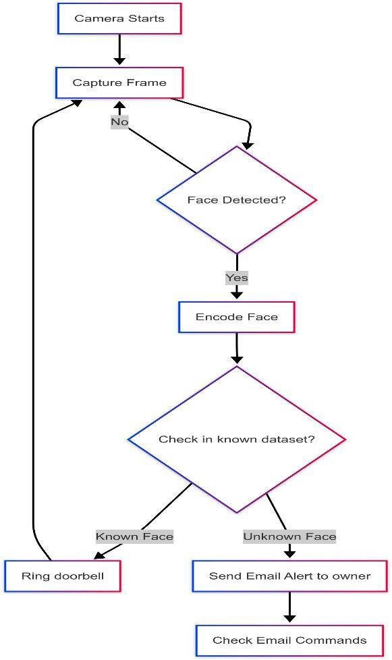

Fig 5.1.1: Flowchart Representing Smart Doorbell and Alert Mechanism

Design and Diagram

    - Usecase Diagram
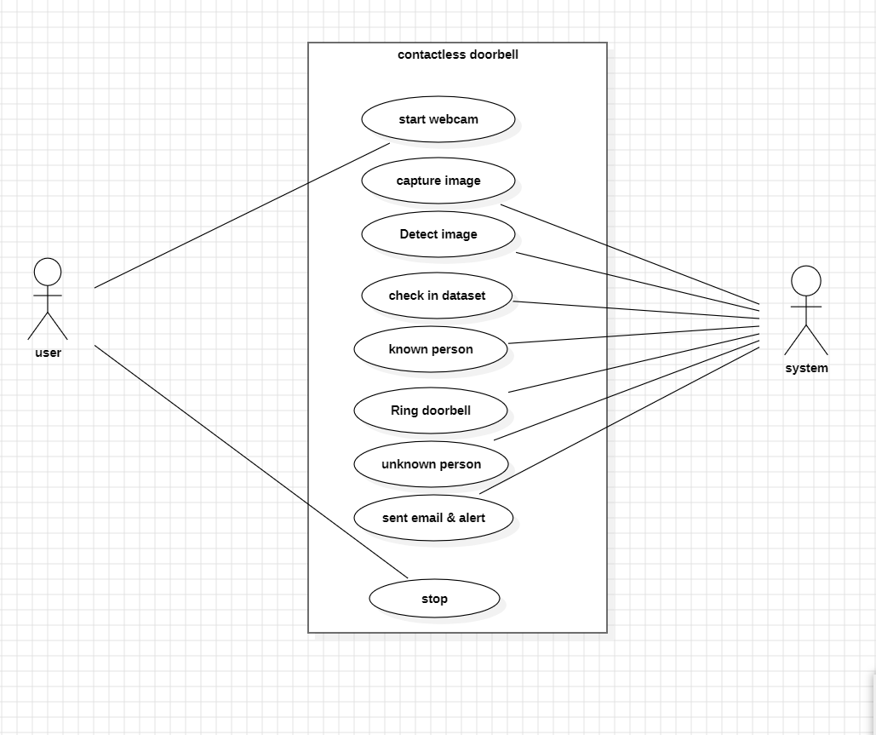
The use case diagram provides a high-level overview of how various actors interact with the Contactless Smart Doorbell System. It illustrates the functional requirements of the system from an end-user's perspective, focusing on user interactions and system functionalities.

Fig 5.2.1: Usecase Diagram for Smart Contact Less Door Bell
This use case diagram shows how a contactless smart doorbell system works using face recognition. It involves two main users: the User (like a homeowner) and the System (the doorbell device). The process starts when the user activates the webcam. The system captures an image of the person standing in front of the door. It then detects the face in the image using image processing techniques. After detecting the face, the system checks if the face matches anyone in its stored dataset. If the face is recognized as a known person (like a family member), the system rings the doorbell.

If the face is unknown, the system does not ring the bell. Instead, it sends an email and alert to the user with the visitor's photo. This helps keep the home secure by informing the user about unknown visitors.
Finally, the system can be stopped after the process is done, saving power and resources.

Class Diagram

The class diagram for the Contactless Doorbell System illustrates the main components and their relationships within the system. It breaks down the architecture into several key classes, each representing a distinct part of the functionality. Here’s an overview of the primary classes and their responsibilities:

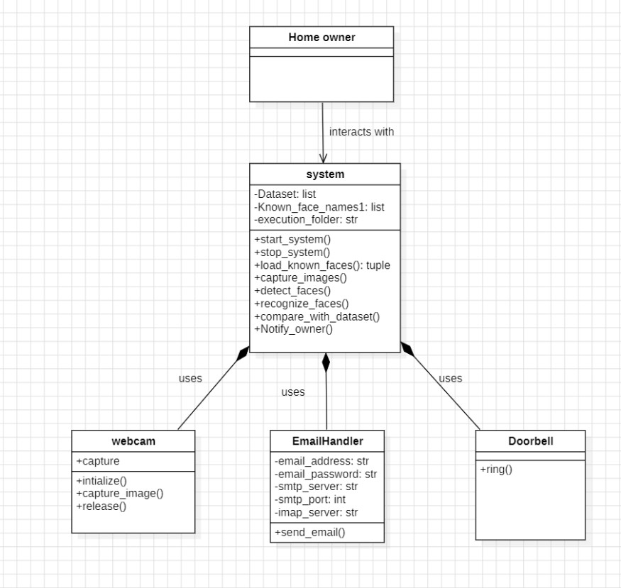

Fig 5.2.2: Class Diagram for Smart Contact Less Door Bell

Home Owner: The Home owner is the user who interacts with the system. This class doesn’t have any attributes or methods because it mainly represents a role that interacts with the system interface.
System: This is the core component of the project, responsible for managing the entire face recognition doorbell operation.
Attributes:
Dataset: stores facial data.
Known_face_names1: list of names of known people. execution folder: directory where images and data are stored. Methods:
start system (), stop system (): control system flow. load_known_faces (): loads existing facial data. capture images (): captures images using the webcam. detect faces (): finds faces in captured images. recognize faces (): identifies the detected face.
compare_with_dataset (): matches detected face with known faces. Notify owner (): alerts the user if an unknown face is found.
Webcam: Represents the camera module used in the system.
Methods: capture (), initialize (), capture_image (), release (): functions to operate the camera — starting it, capturing an image, and releasing it afterward.
Email Handler: Handles email communication to notify the homeowner.
Attributes: Email credentials and server information such as email address, email password, SMTP server, imap_server, and SMTP port.
Method: send email (): sends an alert to the user when an unknown person is detected.
Doorbell: Represents the doorbell hardware.
Method: ring (): triggers the bell when a known person is identified.

Sequence Diagram

The sequence diagram illustrates the flow of interactions between various system components and the user (Homeowner) during the operation of the contactless doorbell system.
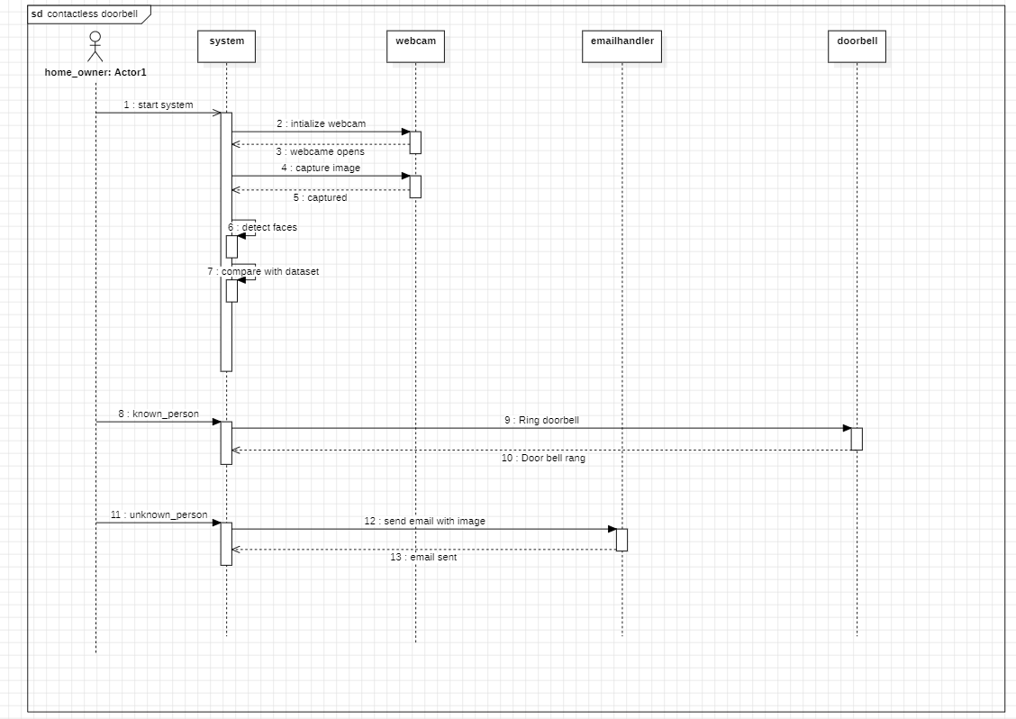

Fig 5.2.3: Sequence Diagram for Smart Contact Less Door Bell

System Initialization: The process begins when the home owner initiates the system (start system). Webcam Activation: The system sends a signal to the webcam to initialize. Once initialized, the webcam opens and captures an image.
Image Capturing: The captured image is then sent back to the system.
Face Detection: The system detects faces within the image and proceeds to compare the detected face with the stored dataset.
Face Recognition: If the face matches someone in the dataset (i.e., a known person), the system commands the doorbell to ring. This notifies the home owner of a familiar visitor. If the face is not recognized (i.e., an unknown person), the system uses the email handler to send an email to the home owner. This email includes the captured image of the visitor as an alert. Notification completion: The email handler confirms that the email has been successfully sent.

Collaboration Diagram

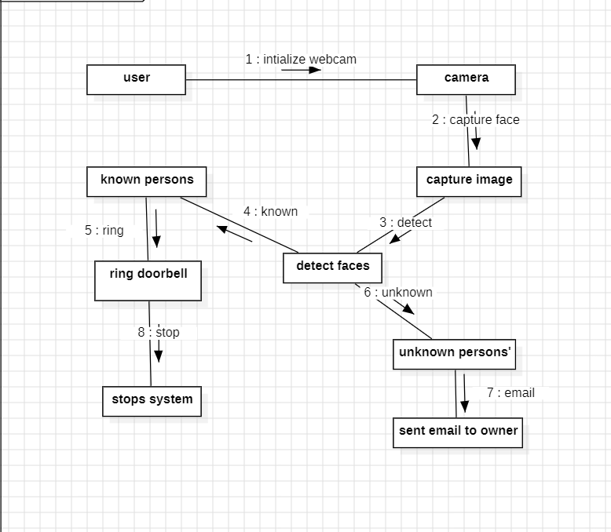
The collaboration diagram illustrates the interaction between different components of the smart contactless doorbell system. It shows how objects work together to complete the process of person detection, recognition, and door access control based on verification by the homeowner.

Fig 5.2.4: Collaboration Diagram for Smart Contact Less Door Bell

- The user starts by initializing the webcam.
- The camera then captures the visitor's face.
- This face image is passed on to the face detection component, where the system attempts to detect faces from the image.
- The system checks the detected face against a dataset to determine if the person is known or unknown.
- If the person is known, the system proceeds to ring the doorbell.
- If the person is unknown, the system triggers an email to be sent to the owner along with the captured image.
- The system concludes the process by stopping automatically.

21

Data Flow Diagram

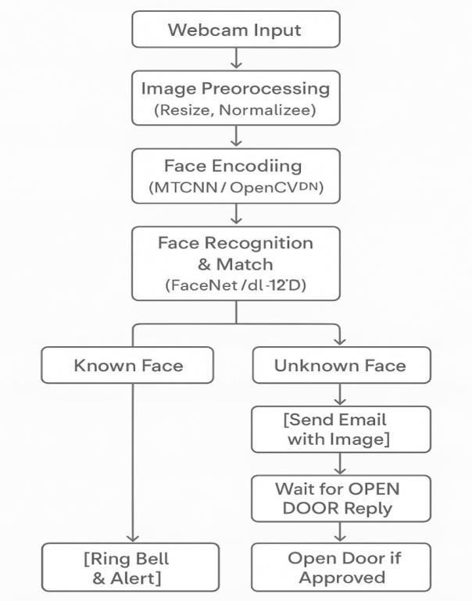

Fig 5.2.5: Dataflow Diagram for Smart Contact Less Door Bell

This diagram outlines the workflow of an automated facial recognition-based door access system. The process begins with a Webcam Input, which captures a live image of the individual at the door. This image then undergoes Image Preprocessing, where it is resized and normalized to ensure consistency and quality for further analysis. The next step is Face Encoding, where facial features are extracted using models such as OpenCVDN. These encoded features are then passed into a Face Recognition & Match stage, utilizing models like FaceNet or dL-12'D to determine whether the face matches any image in the known database. If the system recognizes the face as a Known Face, it proceeds to Ring the Bell & Alert, allowing authorized access. However, if it detects an Unknown Face, it triggers a security protocol by Sending an Email with the Image to the concerned party.This process ensures both convenience and security by combining real-time face recognition with manual override for unrecognized individuals.

CHAPTER 6 METHODOLOGY

The methodology for the Smart Contactless Doorbell System follows a structured five-phase approach combining computer vision and IoT technologies. First, facial images are captured in real-time using a USB webcam and preprocessed through downscaling and RGB conversion for optimal processing. Next, the system employs OpenCV's Haar Cascade classifier for face detection followed by dlib's ResNet model to generate 128-dimensional facial embeddings for recognition. Detected faces are then matched against a registered database, triggering personalized audio greetings for known individuals while generating email alerts with snapshots for unknown visitors. Finally, the system integrates an IMAP email parser to enable remote door control commands, completing an end-to-end automated security solution with local processing for enhanced privacy.

DATA DICTIONARY
The Smart Contactless Doorbell System utilizes structured data entities to manage facial recognition, event logging, and security alerts. The system maintains three core data categories:
Registered User Profiles: Each authorized individual is stored with a unique numeric identifier (`face_id`), their full name in string format (`person name`), and the 128-dimensional facial embedding (`face_encoding`) generated by the dlib ResNet model. The registration timestamp (`date registered`) follows ISO 8601 format for audit purposes.
Event Logging: Every face detection event records the occurrence time (`detection time`), camera source identifier (`camera_id`), and recognition outcome (`is recognized`). The confidence score (`confidence score`) stores the match probability between 0.0 (no match) and
1.0 (exact match).
Security Workflow Data: Unrecognized faces trigger snapshot storage with system-generated paths (`snapshot path`) and email alert status tracking (`email sent`). The email subsystem logs recipient addresses (`recipient_email`), attachment references (`attachment_path`), and any parsed remote commands (`command_received`).

DATA COLLECTIONS
    - Primary Data Acquisition
Facial images are captured in real-time using USB or IP cameras at 720p resolution (30fps). Each frame undergoes automatic quality validation, rejecting images with:
Low lighting (<50 lux measured via sensor)
Excessive motion blur (threshold: 0.5 Laplacian variance) Partial face occlusion (>30% coverage)
    - Biometric Processing Pipeline
Valid frames are converted to RGB format and downscaled to 320x240 pixels for processing. The system extracts:
Spatial Data: Face coordinates (x, y, w, h) via Haar Cascade Feature Data: 128-dimension embeddings using dlib's ResNet-34 Raw pixel data is discarded immediately after feature extraction.
    - Data Categorization Collected samples are classified as:
Known Faces: Stored in `/dataset/<person_name>/` with encrypted metadata
unknown Faces: Temporarily archived in `/unknown_persons/` (auto-purged after 72 hours) System Logs: Anonymized event records with timestamp, camera ID, and confidence score
    - Consent & Compliance The system implements:
Opt-in Registration: Explicit user consent via physical button presses during enrollment Right to Erasure: CLI tools for profile deletion (`python3 unregister.py --id 1001`)
Data Minimization: Only essential facial vectors are retained (no raw images post-processing)
    - Security Protocols All stored data features:
AES-256 encryption at rest

PREPROCESSING TECHNIQUES

Normalization:
Normalization in image processing is a technique used to adjust the range of pixel intensity values in an image. It’s especially useful when preparing images for computer vision or machine learning tasks. The main goal is to bring all pixel values to a common scale, which can improve contrast, make images more consistent, and enhance the performance. Other methods include Z-score normalization, where pixel values are standardized based on the image’s mean and standard deviation. Normalization is widely used in tasks like image classification, object detection, and deep learning because it helps models converge faster and perform better. It also ensures that all input images have similar brightness and contrast levels, reducing the impact of lighting variations.

Min – Max Normalization:

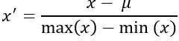

One – Hot Encoding:
One-hot encoding is a common data preprocessing technique used to convert categorical variables into a numerical format that can be used by machine learning models. Since most algorithms cannot work directly with non-numeric data (like names or colors), one-hot encoding transforms each unique category into a separate binary column. In this process, for each record, the column representing the actual category is set to 1, while all others are set to
0. For example, a feature like "Color" with values ["Red", "Green", "Blue"] would be converted into three new columns: "Red", "Green", and "Blue". If a row's value is "Green", only the "Green" column will have a 1, and the others will be 0. This avoids giving misleading numerical relationships (like Green > Red), which could happen with simple label encoding. One-hot encoding is widely supported in Python libraries such as Pandas (using pd.get_dummies ()) and Scikit-learn, and is an essential step when working with nominal categorical data in machine learning pipelines.

6.3 PREPARED DATA
The Smart Contactless Doorbell System uses structured datasets for face recognition, consisting of:
- Registered Faces
Format: Folders per person (`/dataset/John_Doe/img1.jpg`)
Content: 5-10 high-quality images per person (front-facing, varied lighting) Preprocessing: Auto-aligned and normalized to 150×150 px grayscale.
- Unknown Faces
Storage: Timestamped JPEGs in `/unknown_persons/` (auto-deleted after 7 days).
- Metadata
SQLite Database: Logs recognition events (timestamp, confidence, camera ID). Key Features:
Privacy: Raw images discarded post-processing; only facial encodings (128D vectors) stored.
The prepared data for the smart doorbell system plays a crucial role in the effectiveness of facial recognition. To build a reliable dataset, images of known individuals—such as family members, frequent visitors, or authorized personnel—were collected manually. Each individual’s images were stored in separate folders under the main dataset directory, where each folder was labeled with the person’s name. These images were captured in various lighting conditions and facial angles to improve recognition accuracy. Before use, all images were preprocessed using OpenCV: converted to grayscale, resized, and normalized to ensure consistency and reduce computational overhead during training and recognition. The more diverse and clean the images in the dataset, the better the model can recognize the person in real-time video feeds.

Training
CHAPTER 7 MODEL

The project it uses pre-trained models from the face_recognition library (which is built on top of dlib and ResNet CNN). The training, involves encoding faces from a dataset of known persons and storing those encodings for comparison during real-time recognition.

Dataset Preparation
The training process in the project begins with preparing a structured dataset of known individuals. This dataset is organized in a folder named dataset/, where each subfolder represents a unique person and contains one or more images of that individual. For example, the folder might have a subfolder called Alice containing img1.jpg and img2.jpg, and another called Bob with img1.jpg. Each image is expected to clearly capture the person’s face from a front-facing or slightly angled view. This organization is crucial because the name of each folder is automatically associated with the identity of the person during face recognition. The system uses these names as labels when later comparing faces during real-time operation. Face Detection and Encoding
Once the dataset is ready, the system proceeds to analyze the images to detect and extract facial features. This is done through a function in your code called load_known_faces(). Inside this function, each image is read and converted from BGR to RGB format (since OpenCV loads images in BGR by default, but face_recognition expects RGB). The system then detects the face(s) in the image using a pre-trained face detection model (under the hood, this uses CNN-based method provided by the dlib library). After locating the face, it computes a face encoding — a 128-dimensional numerical representation that captures the most distinct features of a face. The encoding vector is highly unique for each individual, yet consistent across different images of the same person. These encodings are then stored, effectively creating a trained "face library" that can be referenced during real-time recognition.

Memory-based Model Training
In traditional machine learning, training involves optimizing model parameters by feeding in large datasets and minimizing loss functions. However, this project uses a memory-based approach where the “training” is effectively storing the face encodings in memory. These stored vectors form the core of the recognition system and act as a fixed reference. No neural networks are retrained or updated during this process; instead, the system relies entirely on the high accuracy of the pre-trained models provided by the face_recognition library, which is itself based on a deep convolutional neural network trained on millions of face images (using the ResNet architecture). By storing these 128D encodings in RAM, the system avoids computationally expensive training and allows for quick comparison and recognition in real time.
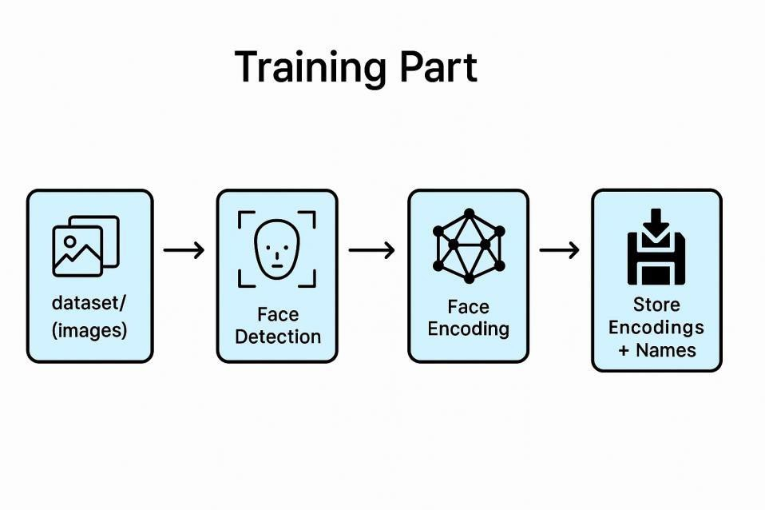

Fig 7.1.3: Training for face recognition

    - Real-Time Face Matching
After the known face encodings are loaded and stored, the system is ready to perform recognition. When a person appears in front of the webcam, the live video frame is processed similarly to the training images: the face is detected and encoded into a 128D vector. The system then compares this vector to each of the stored encodings using a similarity check. This is typically done by calculating the Euclidean distance between vectors.

If the distance between the live encoding and any of the known encodings is below a certain threshold (e.g., 0.5), the system considers it a match and identifies the person using the name associated with the matched encoding.
This threshold is crucial; a low value ensures higher precision but may reject true matches if the lighting or angle differs too much, whereas a higher value may increase false positives. If a match is found, a message is printed, and a bell sound is played. If no match is found, the system assumes the person is a stranger and triggers an alert by saving the image and sending it via email.
To summarize, the system does not involve training a model from scratch. Instead, it leverages pre-trained models for face detection and encoding, using them to extract and store facial feature vectors from a known dataset. This stored data functions as a reference model that the system uses for real-time face recognition through simple vector comparisons. It’s a highly efficient and scalable method suitable for small to medium applications like smart security systems. The training phase, in essence, is the process of converting labeled face images into machine-readable encodings and storing them for future comparison.

Validation
Validation refers to the process of testing a model on unseen data to assess how well it generalizes beyond its training set. While this project does not involve training a model from scratch using backpropagation or epochs, it still includes a validation process — just not in the conventional sense. In this smart doorbell system, validation happens in real time during the face recognition and decision-making phases. It ensures that the face encodings generated from the webcam feed correctly match with those stored from the dataset, or appropriately reject them if they don't match.

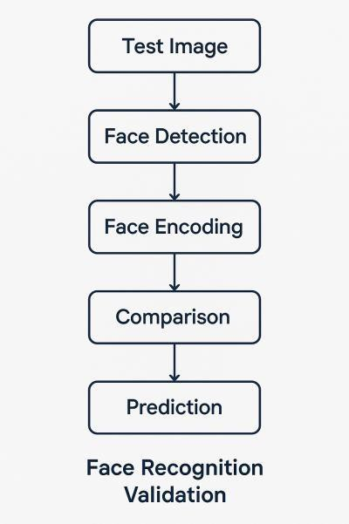.

Fig 7.2: Validation

    - Real-Time Recognition as Implicit Validation
Each time a person stands in front of the door camera, the live image frame is treated as validation input. The system captures the frame, detects the face, and encodes it into a 128-dimensional vector — just like it did during the training phase. This newly generated encoding is then compared against the stored encodings from the known dataset using a similarity metric
      - usually Euclidean distance. If the distance between this input vector and any stored vector is below a certain threshold (e.g., 0.5), the person is recognized as someone from the dataset. Otherwise, they are classified as "Unknown."
This process essentially validates whether the system has stored accurate representations of the faces. If a known person is consistently recognized under different lighting, angles, or expressions, it confirms that the stored encodings are valid and generalizable. If not, the system might fail to recognize known individuals or mistake strangers for someone familiar
      - a sign of poor validation performance.

Threshold-Based Decision as a Validation Filter
Another form of validation comes through the thresholding logic in the recognition code. The face_recognition. compare_faces () function compares the incoming face encoding with each known encoding and returns a list of Boolean values. These are then filtered using the face distance metric, which gives a more nuanced, numerical measure of similarity. By setting a threshold (like confidence_threshold = 0.5), effectively validate whether a match is strong enough to be considered correct.
This threshold acts as a cutoff point to balance between false positives (wrongly recognizing someone) and false negatives (failing to recognize a known person). It can tune this value to increase or decrease the system’s sensitivity, depending on your security needs.

Validation through Feedback Mechanism
This project includes a unique feedback loop via email alerts. When an unknown person is detected and a photo is emailed to the user, the recipient (you or a homeowner) can visually verify whether the person is indeed a stranger or a misclassified known individual. This human-in-the-loop system provides an external validation mechanism that isn't purely algorithmic. If the system consistently fails to recognize known people or frequently alerts for strangers who are actually family members or guests, you may decide to retrain by adding new images or adjusting thresholds.

Manual Dataset Validation
Another subtle but important validation step is manual dataset curation. If a known person is frequently misclassified or not recognized at all, the most probable cause is poor-quality training images — maybe the image is blurry, poorly lit, or has the person wearing sunglasses. In such cases, validation involves revisiting the dataset, removing low-quality images, or adding better ones. The validation process in the project happens during real-time operation. The system validates the effectiveness of its stored face encodings by comparing them against live webcam inputs and making recognition decisions based on similarity thresholds. Additional validation is provided by user feedback via email alerts and by curating the training dataset to include clearer, more representative images.

CHAPTER 8 SOFTWARE DESCRIPTION
The Deep learning Based Human detection and Recognition for Contactless Doorbell System is an integrated software application designed to enhance home security through real-time facial recognition and automated alerts. The core idea behind this system is to use a webcam to monitor visitors at the door, intelligently identifying whether the visitor is known or unknown, and responding appropriately. The software is developed using Python and utilizes several powerful libraries and tools to handle computer vision, web interface integration, and email communication. The backend of the system is powered by Flask, a lightweight web framework, which manages routing, camera operations, and interaction between the user interface and the core logic.
The face recognition component, which is implemented using the face_recognition library, an easy-to-use wrapper around dlib’s deep learning facial recognition functionalities. Upon initialization, the system loads a dataset of pre-captured images of known individuals. These images are encoded into numerical vectors (face embeddings), forming the "training" part of the system. These encodings are then stored in memory for real-time comparison. When the webcam is activated, the software begins processing video frames, detecting faces within each frame and encoding them in the same way as the known images. This newly captured encoding is then compared against the dataset using a similarity threshold. If a match is found, the system identifies the person by name and plays a doorbell sound using the playsound library, indicating a welcome visitor.
On the other hand, if the detected face does not match any of the known encodings, the system identifies the person as "Unknown". In this case, it captures an image of the face, saves it temporarily, and sends an alert email to the homeowner using Python's built-in smtplib library. This email contains the captured image as an attachment and a brief message describing the time and location of the detection. The email sending operation is handled asynchronously using the threading module to ensure that the main video stream remains uninterrupted. Once the email is sent, the captured image is deleted from the system to avoid storage clutter and maintain privacy.

The user interface offers three main options: start camera, stop camera, and logout. When a user clicks the "Start Camera" button, it triggers a backend Flask route that begins video capture. The live video feed is streamed to the webpage using an MJPEG stream generated from OpenCV frames. Similarly, the "Stop Camera" button terminates the stream, and "Logout" redirects the user back to the homepage. This frontend provides a seamless way to interact with the system without requiring direct access to the backend code.
The overall software is designed with modularity and ease of use in mind. It includes folders such as dataset/ for storing known face images and unknown_persons/ for temporarily saving images of unidentified visitors. With this structure, adding a new known person is as simple as adding their image to the appropriate folder. Additionally, the app reads secure credentials (such as the email password) using environment variables, adding a layer of security to the deployment. The system can be run on any machine with a webcam, making it accessible and scalable for home or small office use.
In summary, the Smart Doorbell System combines real-time facial recognition, live video processing, and instant alert mechanisms into a cohesive application. It not only automates the visitor identification process but also ensures that the homeowner remains informed and secure, even when away from home. The use of modern technologies like Flask, OpenCV, and face recognition libraries ensures high performance, while the simplicity of the user interface makes it suitable for non-technical users. The software represents a practical example of how artificial intelligence and automation can be applied to everyday problems to create intelligent, responsive systems.

CHAPTER 9 SYSTEM TESTING

Literature on Testing
System Testing is a critical phase in the development of the Smart Doorbell System, ensuring that all integrated modules work together as expected. The system was tested different functionalities including face detection, recognition, alert notifications, video streaming, and user interface interaction. Testing was performed in a real-world environment using a webcam and a prepared dataset of known individuals, simulating conditions similar to those of a home entrance.
The first stage of testing focused on the camera and face detection functionality. Upon activating the camera using the web interface, the system was able to continuously capture video frames and detect faces using the face_recognition library. Tests were conducted with both single and multiple people in the frame, under varying lighting conditions. Any minor detection lags were traced back to hardware limitations or low lighting, which were mitigated by adjusting brightness settings or using artificial lighting.
Next, the face recognition accuracy was tested. A set of known faces was loaded from the dataset/ directory, and individuals whose photos were stored were asked to stand in front of the camera. The system correctly recognized and labeled these individuals in real-time, playing the doorbell sound to indicate a known visitor. The confidence threshold was fine- tuned to
0.5 to maintain a balance between accuracy and false positives. For unknown individuals whose faces were not part of the dataset, the system consistently labeled them as "Unknown", confirming the effectiveness of the recognition boundary and threshold.
Email alert functionality was another vital component that underwent rigorous testing. When an unknown person was detected, the system captured a photo and triggered an email alert to the registered account. This was tested by intentionally presenting unknown faces to the camera. The system successfully sent an email containing the correct image and detection time, and subsequently deleted the temporary file from the unknown_persons/ folder. Email login using the app-specific password was tested with Gmail’s SMTP service to ensure security and delivery success, even when tested on different networks.

The web interface was tested for responsiveness and correctness of functionality. The buttons for starting and stopping the camera, as well as logging out, worked as intended and consistently triggered the appropriate Flask backend routes. The live video feed streamed correctly in the browser using MJPEG, with minimal latency. Browser compatibility testing was performed using Chrome, Firefox, and Edge, all of which successfully rendered the UI and displayed the video feed without distortion or alignment issues.
The final stage involved system integration and stress testing. The entire system was allowed to run continuously for extended periods, simulating real-time usage. This testing ensured memory stability, proper camera handling (release and re-initialization), and concurrent thread handling during email alerts. No crashes or freezes were observed during the stress testing, confirming that the application is stable and robust under load.
Overall, the system passed all functional and non-functional testing criteria. It demonstrated reliable performance, real-time responsiveness, and seamless integration between frontend and backend components. The success of the testing phase confirms the system’s readiness for deployment in a real-world environment as an intelligent, secure, and user-friendly doorbell system.

Unit Testing
Unit testing involves testing individual units or components of your code in isolation. For your project, this could include:
- Testing face encoding loading:
Does load_known_faces () return the correct number of encodings? Can it handle missing or corrupt images gracefully?
- Testing face matching logic:
Given known face encodings and a test image, does the system identify the correct person? What happens when no match is found?
- Testing email sending:
Does send_alert () work without a valid app password? Is the email correctly composed with an attachment?

- Testing camera logic:
Is the camera properly released in /stop_camera?
What happens if it is accessed before being initialized?

Unit testing is a crucial part of software development that focuses on verifying the smallest testable parts of an application—individual functions, methods, or classes—independently from the rest of the system.
In the Smart Doorbell System project, while the core functionality revolves around real-time face recognition, email alerts, and camera streaming, unit testing is not explicitly implemented in the provided code. Instead, the system is currently validated through manual and integrated testing during runtime. However, implementing unit tests would significantly enhance the system's reliability, especially when scaling or introducing new features.

For instance, the function responsible for loading face encodings from the dataset could be tested to ensure it correctly processes image data and handles exceptions such as unreadable or corrupt files.
Similarly, the face recognition logic could be tested by providing known and unknown face encodings to confirm that the matching mechanism behaves as expected. Email functionality, which is vital for the alert system, can also be tested using mock objects to simulate email sending without actually dispatching messages. These unit tests not only ensure that individual components work correctly in isolation but also make future debugging and updates much easier.
Integrating a unit testing framework like unittest or pytest would enable automated testing of critical functions, helping to identify errors before they impact the system in production.

In conclusion, while the current implementation does not include formal unit tests, adding them would be a valuable enhancement, promoting long-term maintainability and robustness of the Smart Doorbell System.

Integration Testing

- Integrating Face Recognition with OpenCV The system begins by accessing the computer’s webcam using OpenCV. Each frame captured is passed through the face_recognition library, which detects faces and generates unique facial encodings. This module is integrated into the continuous video stream.

- Integrating Dataset for Known Faces at startup, the system loads a pre-defined dataset of known individuals from the dataset/ directory. Each image is processed to extract facial features and store them in memory. These encodings are used in real-time to compare with incoming faces.

- Integrating Real-Time Recognition with Decision Logic as the video stream runs, each detected face is compared to the known encodings. If a match is found, the system identifies the person and triggers an audio notification using the playsound module. If not, it triggers the alert mechanism.

- Integrating Email Alert System for unrecognized faces, the system saves an image and sends an alert via SMTP using the smtplib library. It attaches the photo and sends it to a predefined email address using credentials stored securely (via environment variables)
.
- Integrating Flask Web Framework, the entire backend logic is connected to a frontend user interface using Flask. Routes like /video_feed, /start_camera, and /stop_camera handle real-time interaction between the user and the backend system.

- Integrating Live Video Feed into HTML Interface using Flask and OpenCV, the processed frames are encoded as JPEGs and streamed to the browser using the multipart/x-mixed-replace MIME type. This lets users view the live camera feed directly on the HTML page.

- UI Integration with Button Controls, the frontend interface includes buttons to start/stop the camera and logout. These buttons trigger Flask routes, allowing users to control the system without accessing backend code directly.

- Thread Integration for Non-Blocking Operations, to ensure smooth performance, threading is used when playing sounds or sending emails. This allows those tasks to run in the background without freezing or delaying the video feed or recognition logic.
Integration in a software project refers to the process of combining various modules or components so that they work together as a unified system. In the case of your Smart Doorbell System, integration is a core aspect of its functionality.
The system brings together multiple independent technologies—computer vision (OpenCV + face_recognition), email communication (SMTP via smtplib), web interface (Flask framework), and audio playback (playsound)—into a cohesive workflow that performs real-time face recognition and responds accordingly through a web UI.

The backend, which includes face detection and recognition, is seamlessly integrated with the frontend through Flask routes. For example, when the camera detects a face, it is compared against known encodings loaded at startup. If the face is recognized, the system plays a doorbell sound using playsound; if not, it captures the image and sends an email alert. All this happens while continuously streaming live video to the browser via the /video_feed route.

Another key integration aspect is between the hardware-dependent camera module, which is accessed via OpenCV, and the Flask server, which delivers processed frames to the frontend. This type of integration ensures that real-time detection and decision-making is visually represented on the user interface.
Moreover, the ability to start and stop the camera through UI buttons involves integrating Flask routes with backend logic to control hardware resources dynamically.

Overall, this integration ensures that different subsystems (image processing, UI interaction, and communication services) work in harmony to provide a smooth, real-time smart doorbell experience.
Proper integration also simplifies user interaction, making the system intuitive and effective for end-users without needing to understand the underlying technical complexity.

Acceptance Testing

Acceptance testing for this project focuses on validating whether the overall system performs its intended functions in a user-friendly and reliable manner. This stage ensures that the final product aligns with the original objectives, such as accurately recognizing known individuals, triggering a doorbell sound, and sending alerts when an unknown face is detected. The test is typically conducted in a realistic environment where the doorbell system is set up with a webcam and the necessary dataset.

Test cases involve presenting the system with known faces from the dataset and confirming whether it correctly identifies them and plays the appropriate audio alert. It also involves showing unknown faces to verify whether the system captures the image, stores it, and sends an email notification successfully.

Additionally, acceptance testing includes checking the frontend interface for usability—ensuring that the "Start Camera," "Stop Camera," and "Logout" buttons work smoothly and reflect real-time actions from the backend. The system must also stream live video feed effectively through the browser and recover gracefully from any interruptions like camera disconnection or network issues. If all these functionalities operate correctly and without bugs, the system is considered acceptable and ready for deployment. This testing ultimately verifies that the product is functional, intuitive, and meets the expectations set by users or stakeholders.

Test Cases

Test cases are specific scenarios used to validate that the Smart Doorbell System functions as expected. They help ensure the system correctly identifies known individuals, handles unknown faces, and triggers alerts accurately. By simulating real-world usage, test cases verify both the frontend (UI controls) and backend (face recognition, email alerts) components.

Test Case | Input | Expected  output | Module | Status
Start Camera | User clicks the “Start Camera” button in the web  interface. | The live video stream starts, and face recognition  begins. | 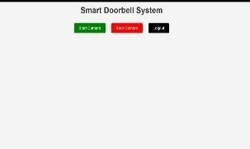 | Pass
Face Recognition known person | A person whose image is stored in the dataset appears in front of the  camera | Displays a green rectangle with name | 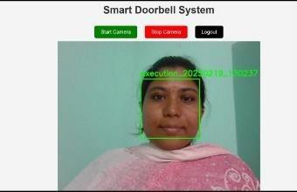 | pass
Face Recognition Unknown person | A new person appears in front of the camera | "Unknown, and sends an email with the unknown person’s photo as an  attachment. | 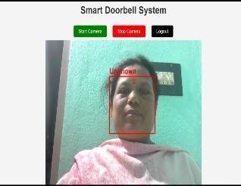 | pass

40

Test  case | Input | Expected result | Result | Status
Email Alert Trigger | Unknown face detected | An email is sent to the configured address with the image and details. | 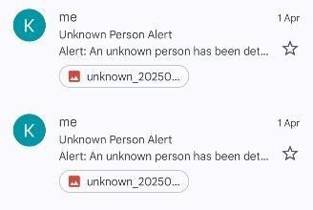 | Pass
Stop Camera | User Clicks the Stop camera  button | The video streams stops and camera is released |  | Pass
Image Storage check | Unknown person detected | Image is saved in unknown_persons/ folder before sending email. | 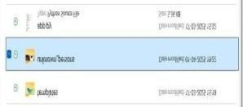 | pass

Table 9.2: Test Cases

CHAPTER 10 CODING
import cv2 import os
import numpy as np
from datetime import datetime import face_recognition
from playsound import playsound import smtplib
import threading import imaplib import email
from email.mime.text import MIMEText
from email.mime.multipart import MIMEMultipart from email.mime.application import MIMEApplication from email.header import decode_header
# Define parameters project_folder = "dataset"
unknown_folder = "unknown_persons" confidence_threshold = 0.5 IMAP_SERVER = "imap.gmail.com" EMAIL = "finalprojectc123@gmail.com"
app_password = os.getenv("EMAIL_APP_PASSWORD")

# Create unknown folder if not exists if not os.path.exists(unknown_folder):
os.makedirs(unknown_folder)

# Load known faces from the dataset def load_known_faces(dataset_folder):
known_face_encodings = [] known_face_names = []
for person_name in os.listdir(dataset_folder):
person_folder = os.path.join(dataset_folder, person_name) if os.path.isdir(person_folder):
for image_name in os.listdir(person_folder):

image_path = os.path.join(person_folder, image_name) image = cv2.imread(image_path)
if image is None: continue
rgb_image = cv2.cvtColor(image, cv2.COLOR_BGR2RGB) face_encodings = face_recognition.face_encodings(rgb_image) if face_encodings:
known_face_encodings.append(face_encodings[0]) known_face_names.append(person_name)
print("Loaded known persons:", known_face_names) return known_face_encodings, known_face_names

# Save and send unknown person's photo via email def handle_unknown_person(frame):
timestamp = datetime.now().strftime("%Y%m%d_%H%M%S") image_path = os.path.join(unknown_folder, f"unknown_{timestamp}.jpg") cv2.imwrite(image_path, frame)
print(f"Unknown person's photo saved: {image_path}") send_alert(image_path)

# Send email alert with the photo and check for commands def send_alert(image_path):
sender_email = EMAIL receiver_email = EMAIL

if not app_password:

print("App password is not set.") return

subject = "Unknown Person Alert" body = f"""
Alert: An unknown person has been detected at your door.

Time of Detection: {datetime.now().strftime("%Y-%m-%d %H:%M:%S")}

Location: Your Home Entrance """

def send_email (): try:
msg = MIMEMultipart() msg["Subject"] = subject msg["From"] = sender_email msg["To"] = receiver_email msg.attach(MIMEText(body))
with open(image_path, "rb") as file:
img_attachment = MIMEApplication(file.read(), _subtype="jpg") img_attachment.add_header("Content-Disposition", "attachment",
filename=os.path.basename(image_path)) msg.attach(img_attachment)
with smtplib.SMTP_SSL("smtp.gmail.com", 465) as server: server.login(sender_email, app_password) server.send_message(msg)
print("Alert email with photo sent.") except Exception as e:
print("Failed to send email:", str(e)) finally:
try:
os.remove(image_path)

print("Unknown person's photo deleted after email sent.") except Exception as e:
print("Failed to delete photo:", str(e))

def check_email_for_commands (): try:
mail = imaplib.IMAP4_SSL(IMAP_SERVER) mail.login(EMAIL, app_password) mail.select("inbox")
status, messages = mail.search(None, '(UNSEEN)') if status == "OK":
for num in messages[0].split():
status, msg = mail.fetch(num, '(RFC822)') if status == "OK":
for response in msg:

if isinstance(response, tuple):

msg = email.message_from_bytes(response[1]) subject, encoding = decode_header(msg["subject"])[0] if isinstance(subject, bytes):
subject = subject.decode(encoding if encoding else "utf-8") if subject.lower() == "open":
print("Command received: Door Open") elif subject.lower() == "close":
print("Command received: Door Close")

mail.logout() except Exception as e:
print(f"Error checking email: {e}")

threading.Thread(target=send_email, daemon=True). start () threading.Thread(target=check_email_for_commands, daemon=True).start()

# Recognize faces and trigger alerts

def recognize_faces(known_face_encodings, known_face_names): cap = cv2.VideoCapture(0)
while True:

ret, frame = cap.read() if not ret:
print("Failed to capture image") break
small_frame = cv2.resize(frame, (0, 0), fx=0.25, fy=0.25) rgb_small_frame = cv2.cvtColor(small_frame, cv2.COLOR_BGR2RGB) face_locations = face_recognition.face_locations(rgb_small_frame)
face_encodings = face_recognition.face_encodings(rgb_small_frame, face_locations)

for face_encoding, face_location in zip(face_encodings, face_locations):

matches = face_recognition.compare_faces(known_face_encodings, face_encoding, tolerance=confidence_threshold)
face_distances = face_recognition.face_distance(known_face_encodings, face_encoding)

if True in matches:

best_match_index = np.argmin(face_distances) name = known_face_names[best_match_index]

print (f"Known person detected: {name}") playsound("ring_sound.mp3")
color = (0, 255, 0) else:
name = "Unknown"
print("Unknown person detected! Sending email...") handle_unknown_person(frame)
color = (0, 0, 255)

top, right, bottom, left = [v * 4 for v in face_location] cv2.rectangle(frame, (left, top), (right, bottom), color, 2)
cv2.putText(frame, name, (left, top - 10), cv2.FONT_HERSHEY_SIMPLEX, 0.8, color, 2)

cv2.imshow("Webcam - Recognition Mode", frame) if cv2.waitKey(1) & 0xFF == ord('q'):
break

cap.release() cv2.destroyAllWindows()
# Main

if _name_ == "_main_":

known_face_encodings, known_face_names = load_known_faces(project_folder) recognize_faces(known_face_encodings, known_face_names)

CHAPTER 11 RESULTS

Screenshots

Web page interface: The live video stream starts, and face recognition begins.

This image displays the user interface of a Smart Doorbell System. At the top center, the title is clearly shown in bold, indicating the system's functionality. Below the title, there are three control buttons for managing the camera operations. The Start Camera button is green, signifying it is used to activate the camera. The Stop Camera button is red, designed to deactivate or halt the camera feed. Next to these is the Logout button in black, which allows users to exit the system securely. The layout is clean and minimalistic, making it user-friendly and easy to navigate.

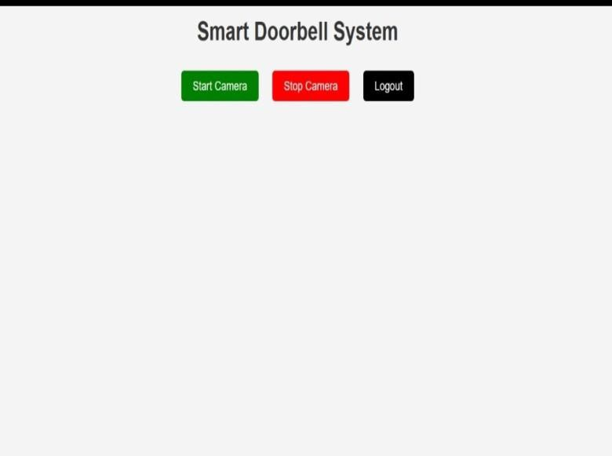

Fig 11.1.1: Web page Interface

Capturing the image: Displays a green rectangle with name for known person

This image shows an active screen of the Smart Doorbell System in use. The interface displays a live camera feed with a person detected in the frame. A green bounding box surrounds the face, indicating that the system has successfully performed face detection. Text near the box (possibly a label or filename like "execution_20230219_130237") suggests that the detected face may be getting saved or logged. Above the feed, the familiar three buttons Start Camera, Stop Camera, and Logout remain accessible for system control. The user appears to be recognized or recorded by the system as part of a smart security process.

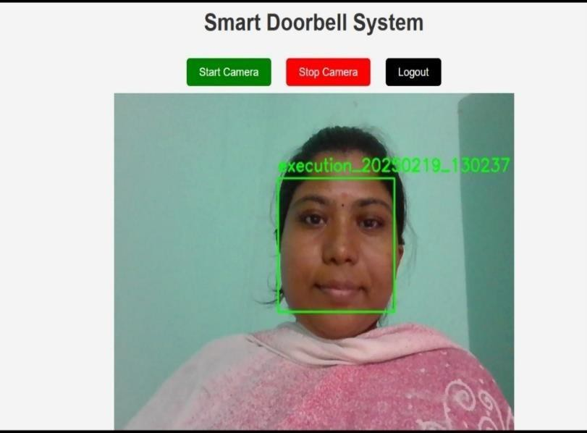

Fig 11.1.2: Known Person Detection

Capturing the image: Displays a Red rectangle with unknown as label for unknown person.

This image depicts a Smart Doorbell System interface actively running with a face detection feature. The camera feed shows a person seated indoors, and their face is outlined by a red bounding box. The label “Unknown” above the box indicates that the system has detected a face but failed to match it with any known or registered individual in its database. This likely triggers a security alert or logging function for unrecognized visitors. The top of the interface retains its control buttons Start Camera, Stop Camera, and Logout for managing the session. The background and attire suggest the person is casually dressed and at a residence. The use of color coding (red for unknown) helps differentiate between recognized and unrecognized identities in real time.

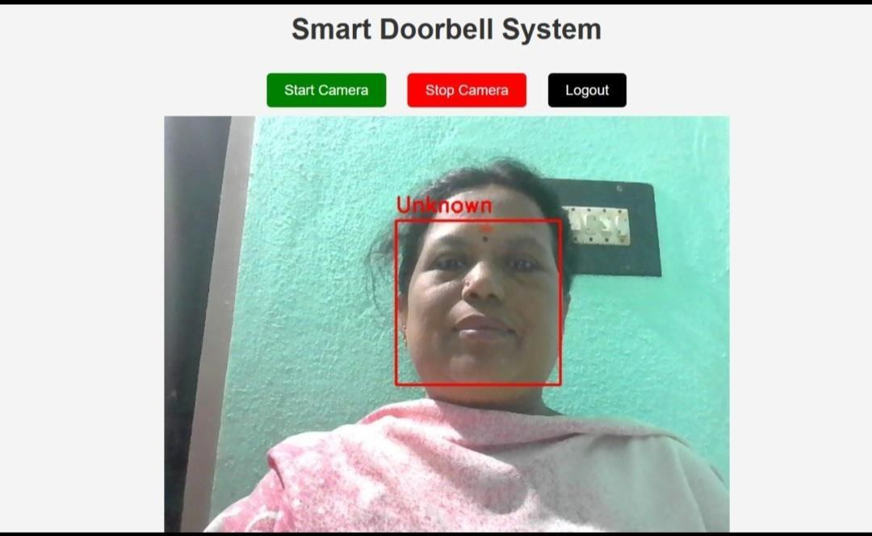

Fig 11.1.3: Unknown Person Detection

Email alert if Unknown person detected: An email is sent to the configured address with the image and details.
This image shows an email alert sent by a Smart Doorbell System regarding an unrecognized visitor. The email, titled "Unknown Person Alert," is sent from a system address to the homeowner. The body of the message states that an unknown person was detected at the door, along with the date and time (2025-04-01 19:20:38) and the location ("Your Home Entrance"). Below the alert text, there is an attached image captured by the doorbell camera, showing the detected individual. This confirms that the system automatically takes a snapshot when an unidentified face is found. The email interface also shows options to Reply or Forward, allowing the user to act quickly. Such automated alerts improve security by informing homeowners of potential intruders in real time.
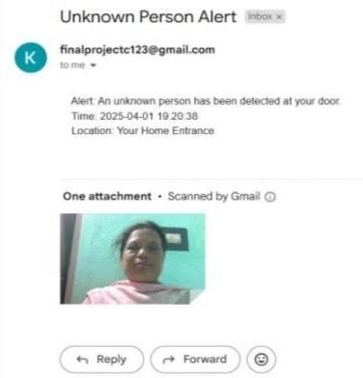

Fig 11.1.4: Email Alert

Conclusions and Limitations

The Contactless Doorbell System showcases how technologies like computer vision, facial recognition, and automated notifications can be combined to improve home security, hygiene, and convenience. Its main objective, minimizing physical contact while ensuring smart visitor interaction has been successfully met through this intelligent system.
Using a webcam or camera, the system captures real-time images of visitors. Recognized faces from a pre-stored dataset trigger an automatic doorbell ring and alert. If the face is unknown, the system captures the image and sends an email with the photo to the homeowner for action. The system is composed of clearly structured components—face recognition, email notifications, and image capture—all operating in a modular and scalable design.
From a user standpoint, the system is fully automated and low-maintenance, requiring manual action only in the case of unknown persons. Its future scope includes cloud storage, mobile app integration, and smart lock control, making it highly expandable. Overall, this project represents a strong step forward in smart home security, blending AI and IoT to deliver safety, convenience, and innovation.

Limitations :
Single-camera limitation: It only supports one webcam at a time (cv2.VideoCapture(0)), so you can't monitor multiple entry points.
Limited hardware support: Only works with a USB webcam; no support for IP cameras or Pi Camera (if deploying on Raspberry Pi).
Multiple email threads: If many unknown faces appear in quick succession, multiple threads may send many emails, possibly leading to spam or rate-limiting.
No background face encoding: Face encodings are calculated in real-time per frame, which could slow things down. A more optimized system would batch or cache this process.

Future Scope

While the current smart doorbell system is functional for basic face recognition and sending alerts, it has a lot of potential for future upgrades. As smart home technology grows, the system can be expanded to be more secure, intelligent, and user-friendly. Adding features like cloud integration and better storage will help make the system more robust and track visitor history more effectively.
One major improvement would be adding a database like Firebase or MongoDB to store data about visitors, including their names, images, and visit times. Creating a mobile app could make the system more convenient by sending real-time alerts, showing live video feeds, and allowing users to control the door remotely. This would be especially helpful when users are not at home. Hardware and software upgrades can also take the system to the next level. For example, connecting smart locks or servo motors would let the door open automatically for recognized users. On the software side, using advanced face recognition models like FaceNet could improve accuracy even in tricky conditions like poor lighting. Adding features like HTTPS, user login, and encrypted communication would also boost security and make the system ready for wider use.

Mobile App Integration:
Developing a dedicated Android or IOS mobile application can significantly enhance user experience. The app can send real – time push notifications when someone at the door, stream the live camera feed. Allow users to remotely open or close the door using a simple tap. This makes the system more convenient and accessible, especially for homeowners who are not at home and want to monitor or respond to visitors instantly.

Advanced Hardware and IoT Integration:
The system can be connected to smart locks, servo motors, or IoT devices for full automation. The recognized users can automatically unlock the door when identified, use email or app – based commands to control entry and monitor multiple entry points by integrating with IP cameras or additional sensors.

CHAPTER 12 REFERENCES & BIBLIOGRAPHY
- Ainebyoona Ronard “An IOT Contactless Doorbell and Home Security System with Alerts “, Busitema University, 2022.
- Neil Selwyn, Mark Andrejevic, chris O’Neill, Xin Gu, and Gavin Smith, “Facial Ecognition: Key issues and Emerging Concerns” Cambridge University, pp 11-18,2024

- Vatsal Patel, Sarth Kanani, Tapan Pathak, Pankesh Patel, Muhammad Intizar Ali, and John Breslin, “A Demonstration of Smart Doorbell Design using federated Deep Learning”, Pandit Deendayal Petroleum University and the Conform SFI Research Centre for Smart Manufacturing at the Data science Institute, NUI Galway, Ireland, Oct 2023.
- Rohan Chauhan, Harsh Aryan, and Diksha Bhardwaz, “IOT Based Contactless Doorbell System”, The International Journal of Novel Research and Development (IJNRD), vol. 8, pp. a39-a44, Dec 2023.
- Jaychand Upadhyay, Parkar Rida, Sunidhi Gupta, and Noman Siddique, “Smart Doorbell System Based on Face Recognition” International Research Journal of Engineering and Technology (IRJET), vol. 4, issue. 3, pp. 2840-2843, march 2017.
- KH Teoh, RC Ismail, SZM Naziri, R Hussin, MNM Isa, MSSM Basir, “Face Recognition and Identification Using Deep Learning Approach” Albukhary International University, Kedah, Malaysia, 2014.
- Florian Schroff, Dmitry Kalenichenko, James Philbin, “FaceNet: A Unified Embedding for Face Recognition and Clustering” Google Inc., Proceedings of the IEEE Conference on Computer Vision and Pattern Recognition (CVPR), 2015, pp. 815– 823.

- Wei Liu, Dragomir Anguelov, Dumitru Erhan, Christian Szegedy, Scott Reed, Cheng-Yang Fu, Alexander C. Berg, “SSD: Single Shot MultiBox Detector”, Proceedings of the European Conference on Computer Vision (ECCV), Springer, 2016, pp. 21–37.

- Abhishek Gudipalli, Vaibhav Kejriwal, Vaishnavi Patel, Riddhi Gupta, Utkarsh Dixit, “COVIDbell – A Smart Doorbell Solution for Prevention of COVID-19”, Polish Journal of Biomedical Research, Vol. 2022, Issue 0115, 2023.
- V. Ramya Sri, K. Bhavana, G. Tejaswi, M. Hema Sri, B. Lakshmi Narayana, “Deep Learning-Based Human Detection and Recognition for Contactless Doorbell Systems”, International Journal for Research in Applied Science and Engineering Technology (IJRASET), Volume 11, Issue IV, April 2023.
- G. R. VenkataKrishnan, V. Shrikar, R. Balasubramaniam, G. Madhangi “ SDAFAR: IoT – Based Smart Door Automation Using Face Recognition in Computer Vision “, African Journal of Biomedical Research, Vol. 27, December 2024.
- R. Subash, Yash Kumawat, Vignesh Sivarajan, “ Smart Doorbell System with Facial Recognition for People with Hearing Impairment“ International Journal of Advanced Science and Technology, Vol 12, 2020.
- Khandaker Mohammad Mohi Uddin, “ Smart Home Security Using Facial Authentication and Mobile Application” International Journal of wireless and Microwave Technologies, vol 22, 2022.
- Sarah Abdullah, “ Development of Face Recognition Based Smart Boor Lock” International Journal of Advances in Scientific Research and Engineering, Vol. 15, 2021.
- Asif Rahim, Yanru Zhong, Tariq Ahmad, Sadique Ahmad, Pawel Ptawiak, Mohamed Hammad, “ Enhancing Smart Home Security: Anomaly Detection and Face Recognition in Smart home IoT Devices Using Logit – Boosted CNN Models, MPDI, Vol. 23, Issue 15, August 2023

